Notes from Deep Learning Part 1

Section 2, Lecture 6
- Neural networks are able to provide nonlinear classification using multiple linear classifiers (each neuron performs logistic regression)
- Prediction: given an input vector, how do I calculate output?
- In multiclass classification, each output value of a neural network represent the probability that the corresponding input belongs in a given class.
- In logistic regression, we use gradient descent to determine the weights that determine output (this is training).
- Process
  - Create a brain
    - Initially it is not smart and isn't good at predicting anything
  - Train the brain
    - Teach it how to predict outcomes of our specific type of data
  - Use the brain to predict/classify new data

Section 2, Lecture 7
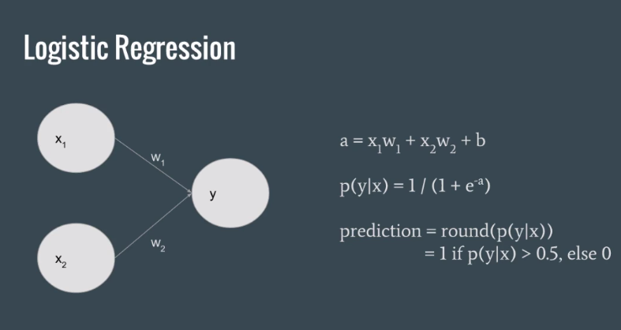
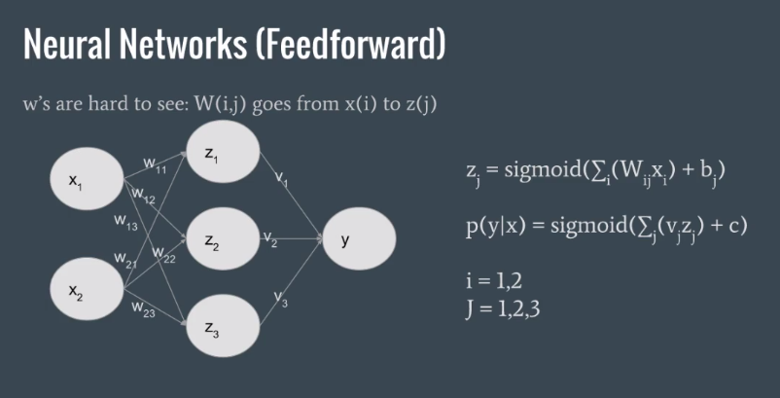
- Three nonlinear classification functions
  - Sigmoid: 1/(1+e^-x)
  - Hyperbolic Tangent: (e^x-e^-x)/(e^x+e^-x)
  - Relu: max(0,x)
    - basically set negative numbers to 0 and pass through positive numbers
    - This works great for computer vision problems.

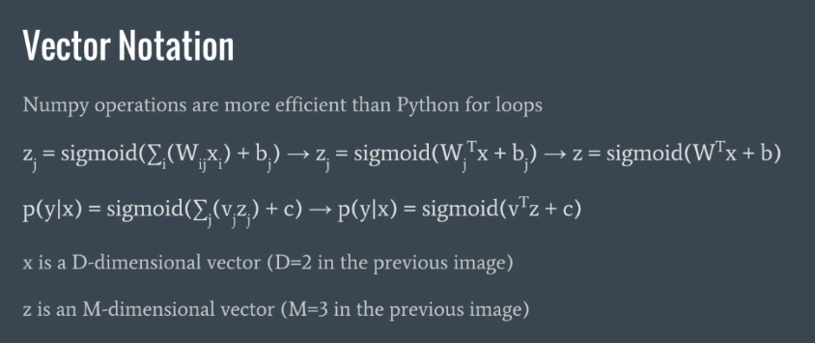
z = sigmoid(np.dot(X,W.T)+b)
y = sigmoid(np.dot(z,V.T)+c)
print('New z: ', z)
print('New y: ', y)

The example above was just for a single entry in the feature matrix.
We actually want to matricize the whole thing so that we use the full feature matrix all at once.
Z = sigmoid(XW + b)
Y = sigmoid(Zv + c)
X is NxD (D = number of samples)
Z is an NxM matrix
Y is an Nx1 vector for binary classification or NxK matrix for multiclassification
You can't really interpret the weights of hidden layers of a neural network.
It's fairly easy to interpret the weights of a single neuron because the weights of each input have a direct linear effect on the output (smoking, exercise, weight have direct correlations to heart disease risk).
However, if you try to do this with a network, it doesn't make sense because the inputs to hidden layers represent mathematical combinations of the previous layers inputs. By trying to place a linear relationship on these complex non-linear interactions, we would limit the capabilities of neural networks.
Really it's just a limitation of our thought process, which is pretty much strictly linear. We aren't able to track and comprehend the meaning of complex non-linear variables.

Section 2, Lecture 9: Softmax
Normally we would just have a single output that represents the probability of one class. The other class is then just 1-firstClass.
We can do this in a different way by having two outputs instead of just one.
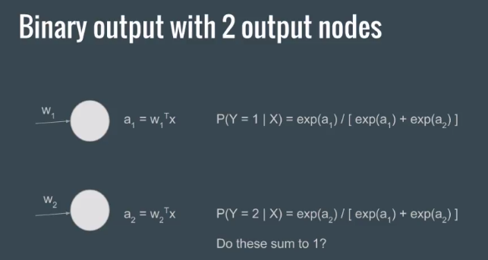
The output is no longer a vector, but a matrix (NxK, where N is the number of inputs and K is the number of classes). We have ensured that the values of these outputs all add up to 1.
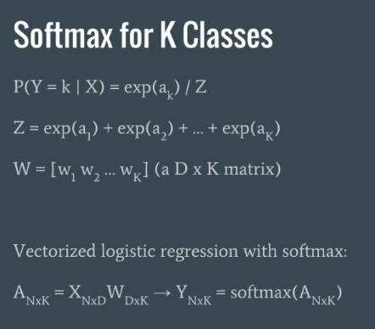
N = number of features
D = number of inputs
K = number of classes
USE SOFTMAX INSTEAD OF SIGMOID FOR MOST MULTICLASS PROBLEMS

Section 2, Lecture 10
- Use Softmax INSTEAD of Sigmoid for all cases because Softmax is more robust and can handle not only 2 class problems but also >2 class problems.

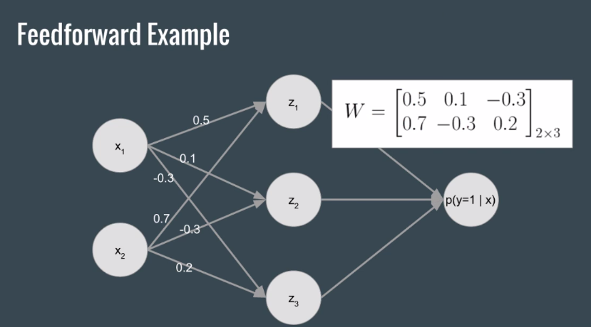
Section 2, Lecture 11, Numerical Examples

